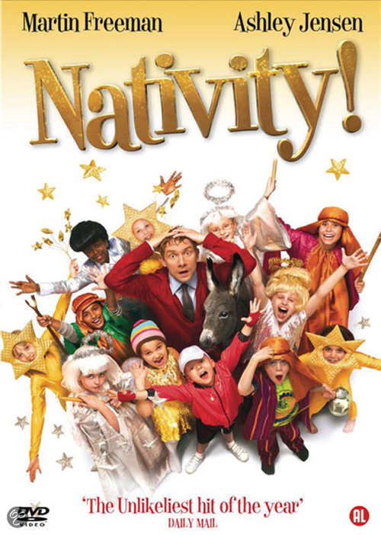
Nativity! (U)
Friday 4th Dec 2015
after school until 5.15

Tickets are £5 inc. popcorn, soft drink, hotdog & crisps.
Please book your place in advance at the school office using the form below and cash or cheque.

Woodborough School Popcorn Club - Friday 4th Dec 2015
Name of child/children:
School class/year:
Number of tickets @ £5 each:
Total enclosed: £
Please make cheques payable to Woodborough School PTA
Please note vegetarian or other dietary requirements:

All proceeds go to Woodborough School PTA funds.

